Lab Exercise19-ClusterIP in Service in Kubernetes

A ClusterIP is the default type of service in Kubernetes. It provides a stable internal IP address for the service, which is accessible only within the cluster. This is useful for internal communication between services within the cluster.

Step 1: Create Deployment (Correct Labels)
Create file:
nginx-deployment.yaml

apiVersion: apps/v1
kind: Deployment
metadata:
name: nginx-app
spec:
replicas: 2
selector:
matchLabels:
app: nginx # MUST match template labels
template:
metadata:
labels:
app: nginx # MUST match service selector
spec:
containers:
- name: nginx
image: nginx
ports:
- containerPort: 80

Save file.

kubectl apply -f nginx-deployment.yaml

Verify:
kubectl get pods --show-labels

You should see:
app=nginx

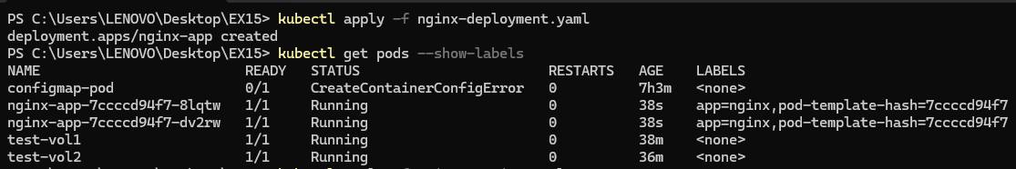

Step 2: Create ClusterIP Service (Matching Selector)

Create file:
nginx-service.yaml

apiVersion: v1
kind: Service
metadata:
name: nginx-service
spec:
type: ClusterIP
selector:
app: nginx # MUST match pod label
ports:
- port: 80
targetPort: 80

Apply:
kubectl apply -f nginx-service.yaml

Step 3: Verify It Is Working
Check Service

kubectl get svc

You should see:
TYPE CLUSTER-IP
ClusterIP 10.x.x.x

MOST IMPORTANT CHECK

kubectl get endpoints nginx-service

Now you should see something like:
10.244.x.x:80, 10.244.x.x:80

Step 4: Test From Inside Cluster
Run test pod:
kubectl run test-pod --image=busybox --rm -it -- sh

Inside pod:
wget -qO- http://nginx-service

You should see:

Welcome to nginx!

Exit:
exit

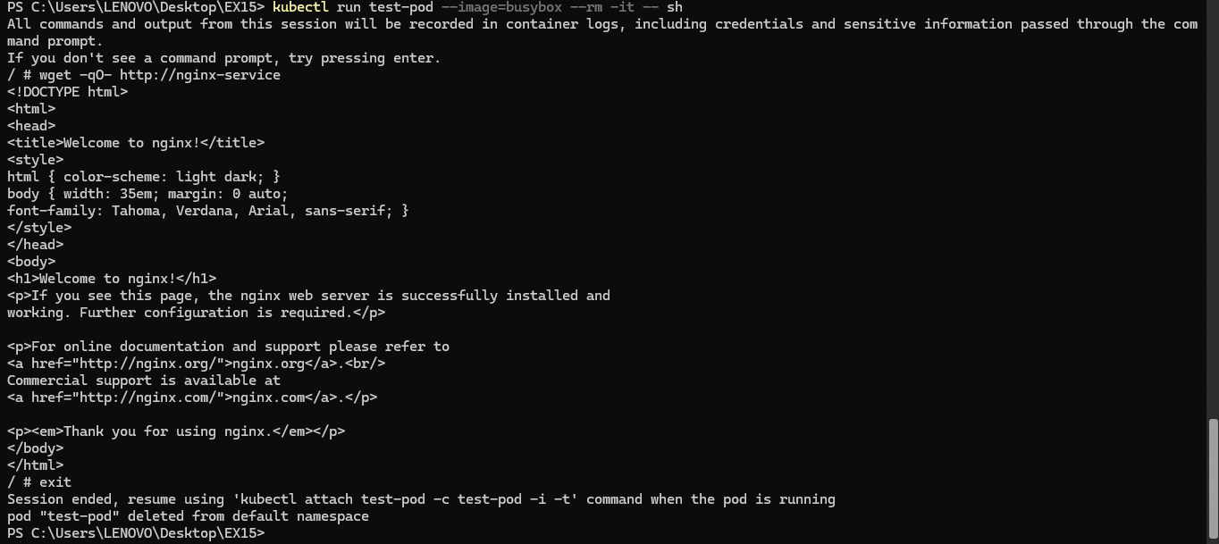

Step 5: Test From Outside (It Will Fail)
From your local machine:

curl http://<CLUSTER-IP>

It will NOT work.
That proves:
ClusterIP works only inside cluster.

